**the ethiopian world federation, incorporateD**

*As Established August 25th1937*

*We, the Black Peoples of the World, in order to effect Unity, Solidarity, Liberty, Freedom, and Self-determination, to secure Justice and maintain the Integrity of Ethiopia, which is our divine heritage, do hereby establish and ordain this Constitution for the Ethiopian World Federation, Incorporated.*

**newsletter**

**OCTOber 2024**

**Welcome to Issue 3. Federation rising!**

|  |
| --- |
| **2024-2025 International Executive Council (IEC)**  Int. President – Dr Winborne  1st Int. VP – Scheril Murray Powell Esq.  2nd Int. VP – Bruce Townsend  IES – Wolete Gabra’el  Int. Treasurer – Pamela Marshall  Int. Organizer – Reuben Kush  Int. Chaplain- A W ProphetElijah  Int. 1st EM – Kebera Baptiste  Int. 2nd EM – Ethelee Barnes  Int. 3rd EM – Rudolph Crossdale |
| **HOW’S OUR NEWSLETTER**  Your feedforward is important to us. If you have missed issue 1 and 2 send us an email and let us know. Give thanks.  C:\Users\fam\Downloads\Screenshot 2024-11-10 072600.pngC:\Users\fam\Downloads\Screenshot 2024-11-10 072448.png |

Dear Members,

As we publish the third edition of our newsletter, we take this opportunity to reflect on the core values that bind us together as an organization: Peace, Love, Unity, and constitutional compliance. In times of uncertainty and challenge, these principles serve as our guiding lights, reminding us of our shared purpose and commitment to one another.

Promoting peace within our organization is paramount in a world that often feels divided. Peace begins with respectful dialogue and empathy. It is essential that we create an environment where every member feels valued and heard. By nurturing a culture of kindness and understanding, we can contribute to a more harmonious community. Let us commit to resolving conflicts through constructive communication and mutual respect.

***Emphasizing, Peace, Love, Unity and Constitutional Compliance***

Love is a powerful force that transcends boundaries, challenges, and adversity.  It can heal wounds, bridge divides, and inspire hope in the darkest times.  When we allow love to conquer us, we open our hearts to compassion, understanding, and connection with others.  This transformative emotion encourages us to rise above our fears and prejudices, reminding us that love is our greatest strength.  Embracing love as a guiding principle enriches our lives and empowers us to create a more harmonious world where kindness and empathy prevail over conflict and division.

Invitation for Locals to advertise their events in our December 2024 newsletter.

Unity is the foundation of our strength. It fosters collaboration and understanding among our diverse members. As we navigate the complexities of our roles, let us remember that our differences enrich our community. By working together, we can overcome obstacles and achieve our common goals. We encourage all members to actively participate in discussions and initiatives that promote inclusivity and solidarity.

Constitutional Compliance - Our constitution is not just a set of rules but a framework that upholds our values and ensures fairness. Compliance with our constitutional guidelines is crucial for maintaining integrity and transparency within our organization. We urge all members to familiarize themselves with our constitution and adhere to its principles. By doing so, we reinforce our commitment to accountability and ethical governance.

As we move forward, let us embrace the ideals of unity, peace, and constitutional compliance. Together, we can build a stronger, more cohesive community that reflects our shared values. Thank you for your dedication and active participation in creating a positive impact.  In unity and solidarity.

Fraternally yours

Wolete Gabra’el - Executive Secretary

**Advisory and Complaints**

Complaints can be submitted in writing directly

to the IEC

Executive Committee

Complaints and Grievances Committee

International Complaints and Grievances Department Secretary

or

Local Chaplain

International Complaints and Grievances Department

IEC

44

IEC

IEC

Advisory

Council of

Elders

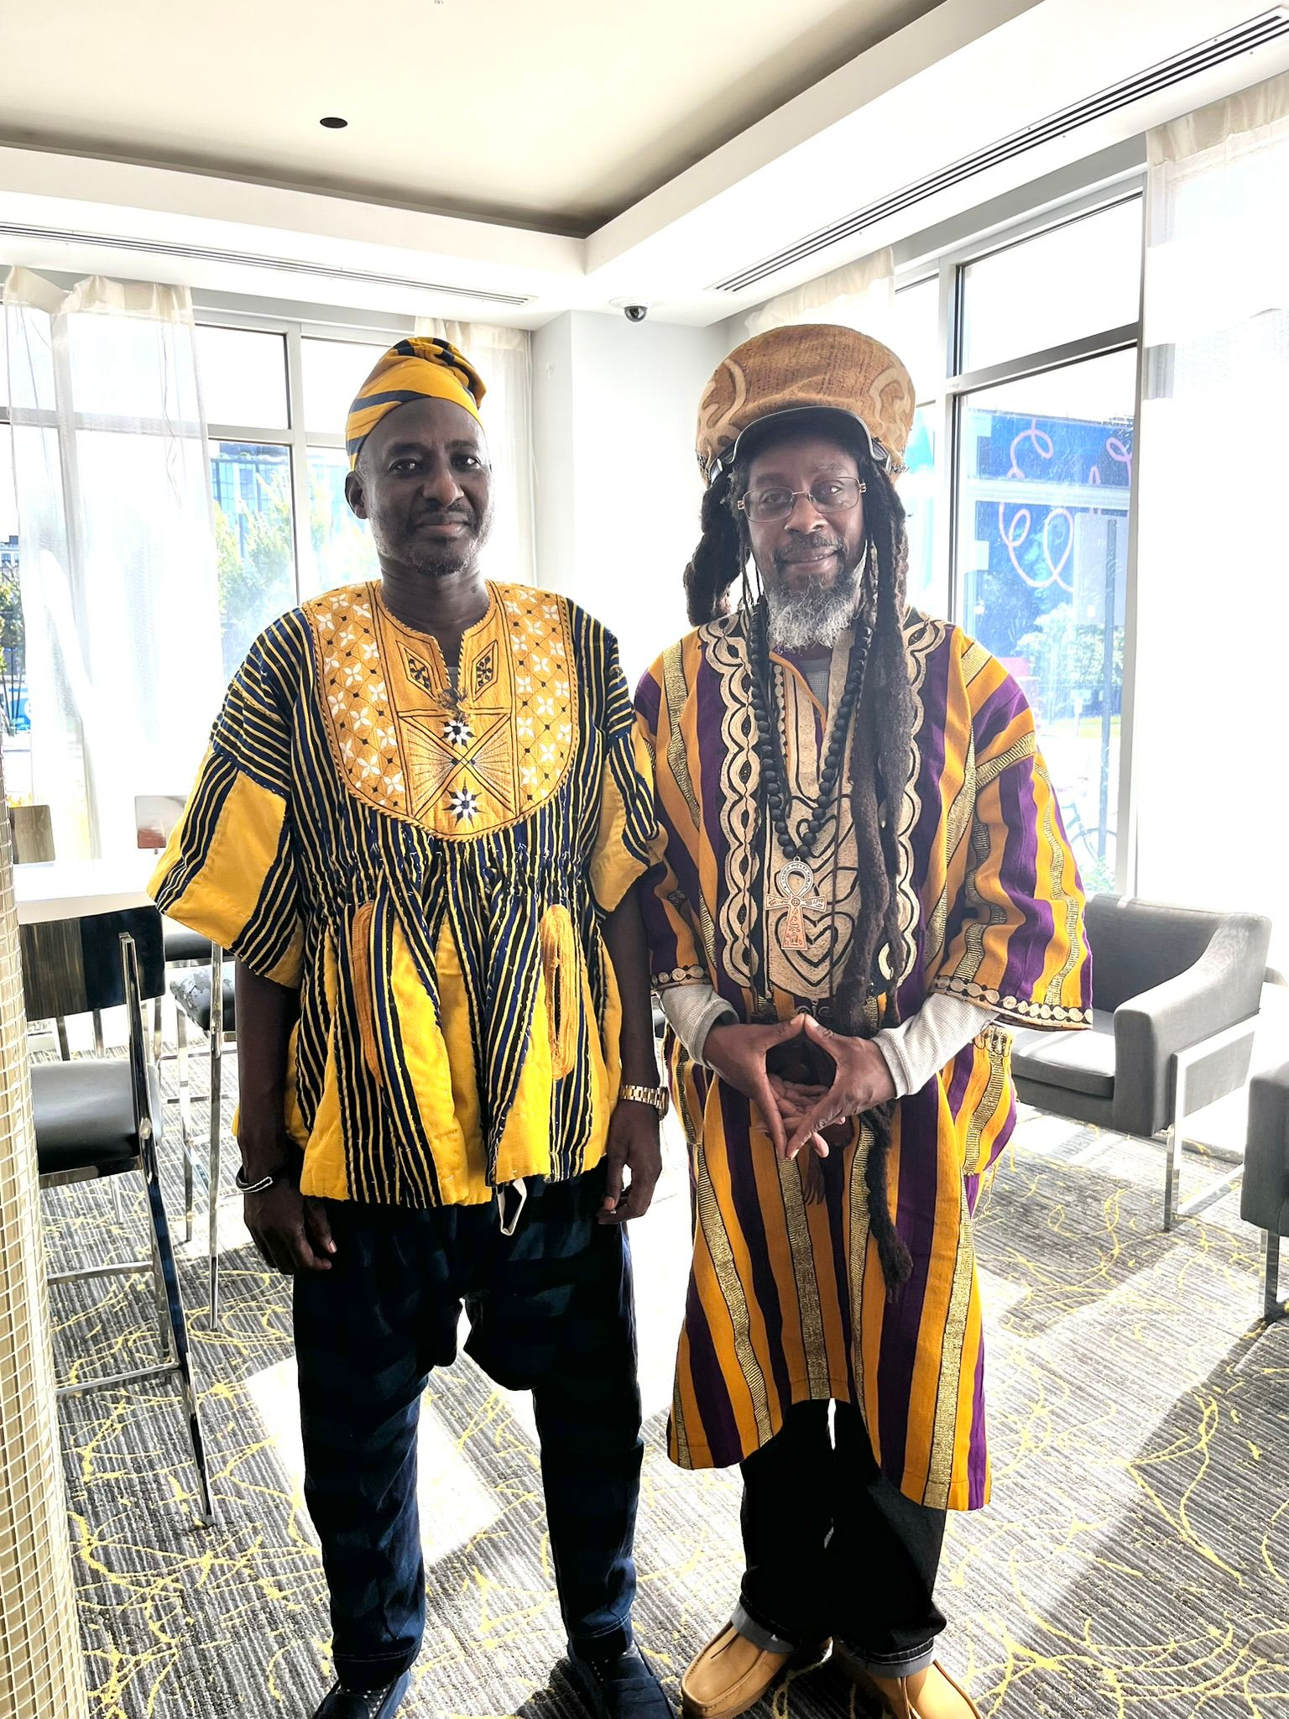Ministry of Foreign Affairs Report

Minister Ras Lazarus Nazari

International 2nd VP IEC/President Local 49

The Ethiopian World Federation, Incorporated (TEWF, Inc.) has recently made remarkable strides in solidifying its position as a recognized state entity under international law. Following the Montevideo Convention's standards, the Federation committed to fulfilling the four main criteria necessary for statehood. With the recent treaty established with the Lakota Nation, a U.S. federally recognized tribal state, TEWF, Inc. now meets all criteria, including forming formal agreements with other states, affirming its standing as a person of international law.

L: His Majesty King Kuoro Barecheh Nlowie Baninye II

R: Minister Ras Lazarus Nazari

As one of the poorest tribes in America, the Lakota have endured hardship, refusing payment for their ancestral lands and facing a long-standing Supreme Court case regarding these lands. Recognizing this resilience, TEWF, Inc., through the Treaty of the Circle of Life sustainability initiative, aims to create lasting, cooperative economic opportunities for both entities. Then the development of our Declaration of Emancipation was developed and sent to the AU and UN with our signed sealed Treaty of the Circle of Life. The Federation’s newly developed Foreign Affairs blueprint encourages self-governance and strengthens the structure for TEWF, Inc. Locals worldwide, empowering them through educational programs on the Montevideo Convention and state sovereignty. Also Local 49 Mahel Sefer is operating as the research Local for a blackprint to our Juridical process with the assistance of our International Chaplain Prophet Elijah.

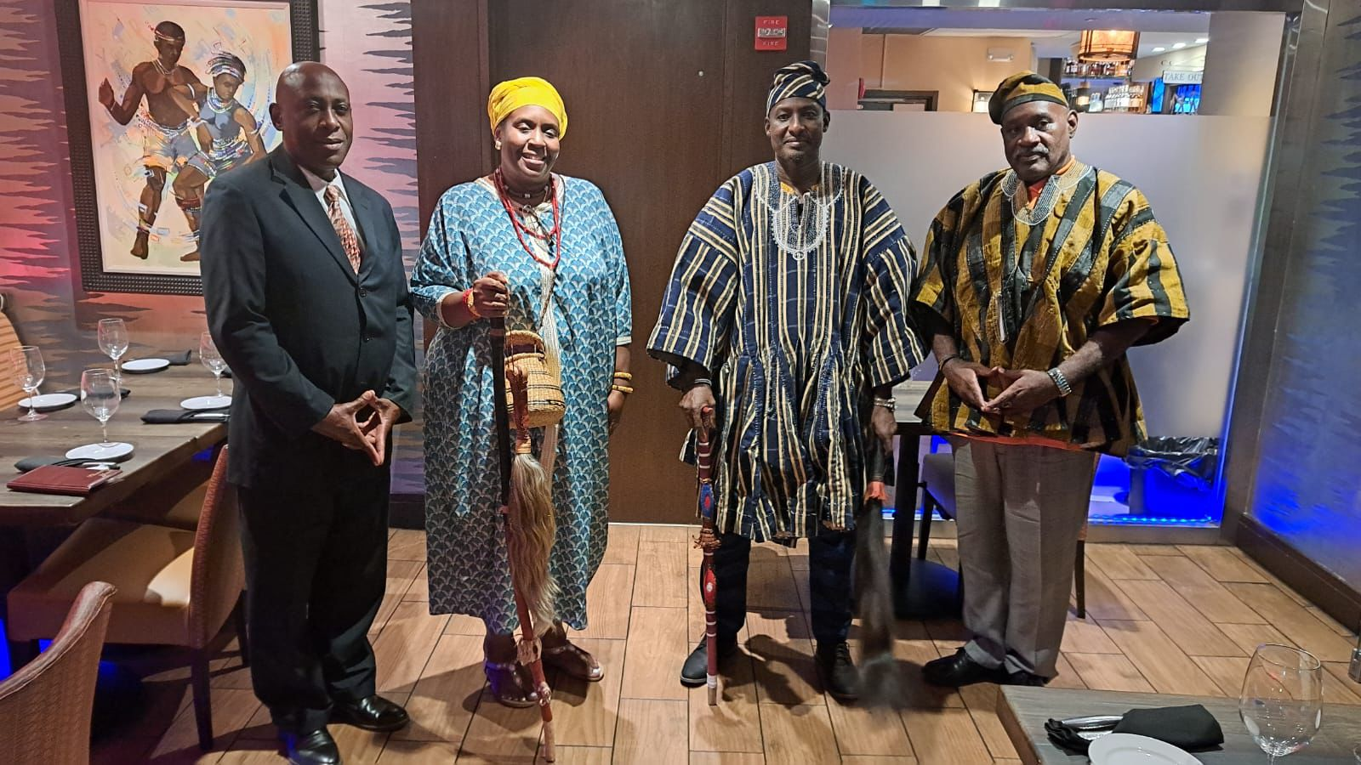In a powerful show of support, the Buwa Kingdom, known for its shea butter production, has granted TEWF, Inc. a generous 1,500-acre land gift in support of repatriation efforts. They have also extended an exclusive offer to the Federation to purchase shea butter at $5.00 per kilo. With the potential to wholesale at $5.00 per pound, TEWF, Inc. members stand to gain significantly. If 200 members contribute $250 to $500 each, it would cover large-scale shipping costs and allow the members to distribute the product widely, creating sustainable revenue opportunities. Our President Dr. James Winborne, Minister Ras Lazarus Nazari and several other members met with His Majesty King Kuoro Barecheh Nlowie Baninye II and his Queen.

Additionally, the Federation is in the process of securing a Tax Residency Certificate within supportive African Kingdoms, which would reduce financial burdens imposed by colonial governments and help sustain TEWF’s mission. With backing from Kingdoms like Buwa, TEWF, Inc. is advancing a unified path towards self-determination, economic independence, and solidarity in preserving Ethiopian sovereignty and heritage.

Any local or member interested in shea butter please contact L49 Women’s Auxiliary, Queen Iffiya +1 984 312 5906.

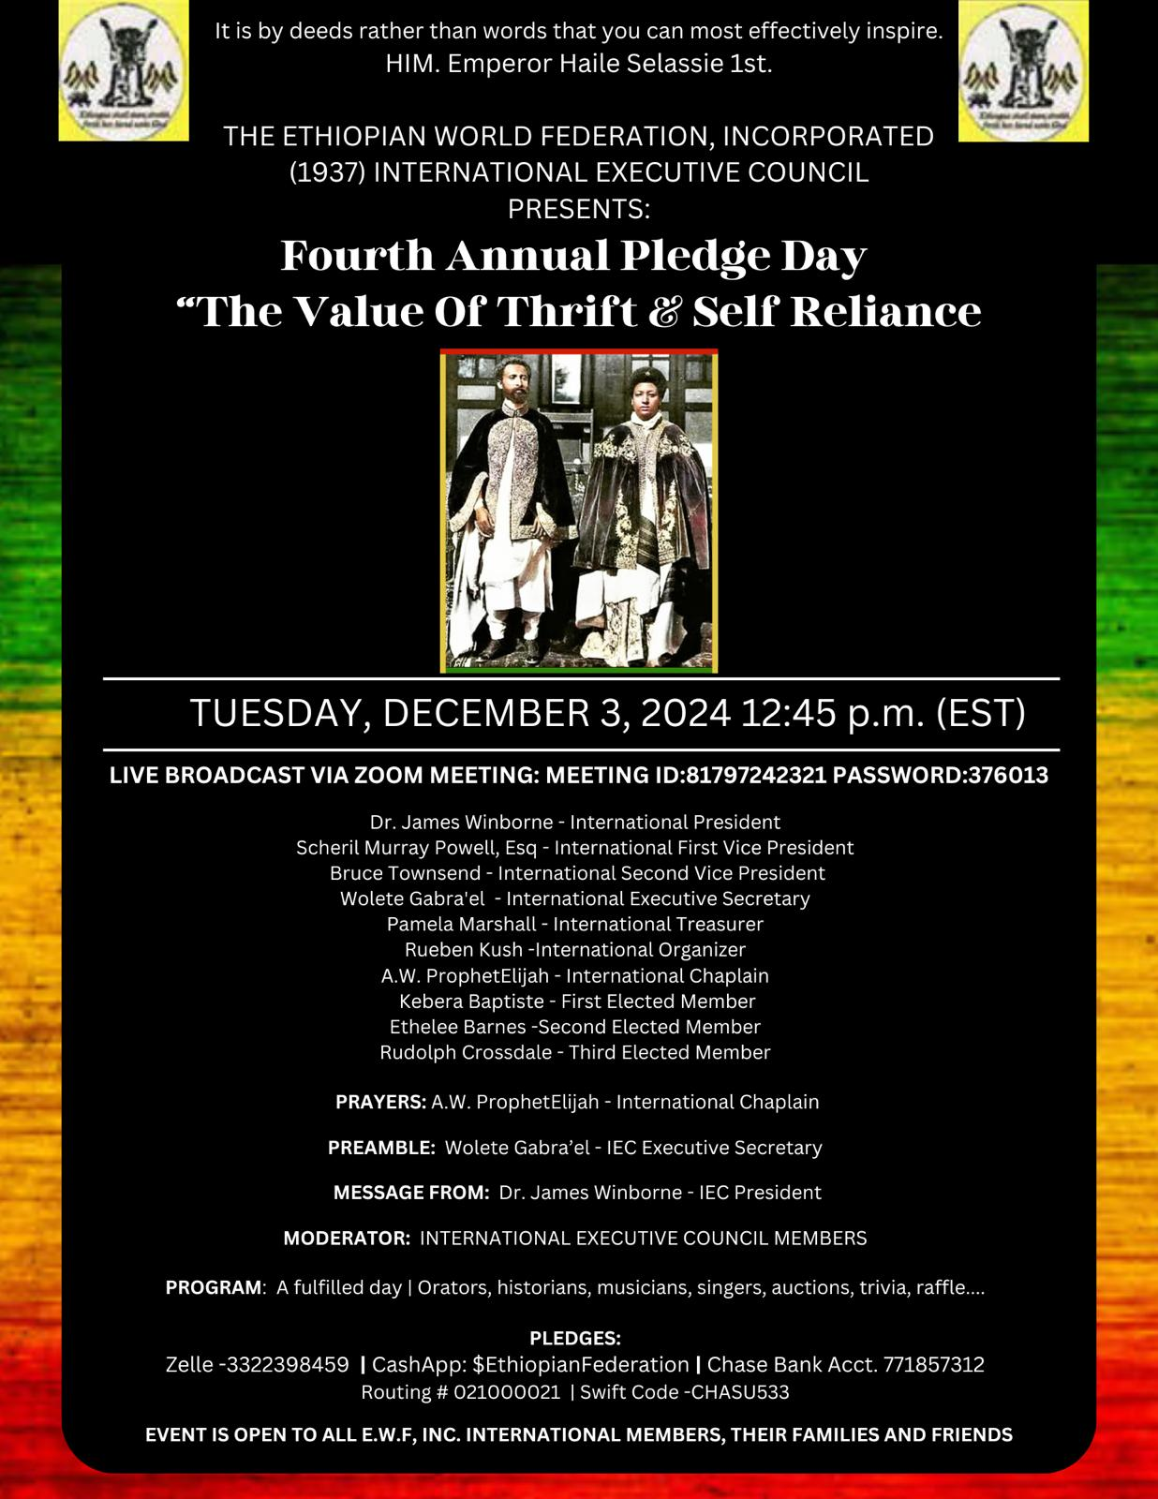

Bank balance as at September 17th 2024.

($7.21)

**Income and Expenditure September 2024**

# 

SCHEDULED MEETINGS EACH MONTH

**2nd Saturday** – Town Hall.

**3rd Saturday** – Local presentation or otherwise.

**4th Saturday** – Guest appearance.

Your participation is essential as we continue to move forward together.

|  |
| --- |
|  |

**Locals**

L2 Los Angeles, USA

L3 London, UK

L5 St Croix, USVI

L7 Martinique

L12 Queens, NY USA

L14 Shashemene, ET

L24 Ghana

L26 Harlem, NY USA

L30 Ghana

L49 North Carolina, USA

L72 Guadeloupe

L101 Addis Ababa, ET

L119 Trinidad and Tobago

L145 Cape Town, SA

L146 Johannesburg, SA

L147 Far Rockaway, NY

PRESIDENTS MEETING

Local’s Presidents meetings **Last Thursday of the month 1pm EST.**

VOLUNTEER POSITION ANNOUNCEMENTS

Please contact your Local for the vacancy announcements to express your interest.

PEP RALLY PLEDGE DAY **November 30th, 1pm.**

PLEDGE DAY (year four)

**December 3rd, 11am.**

Send pledges to:

**Zelle** -3322398459

**CashApp:** $EthiopianFederation

**Chase Bank** Acct. 771857312

Routing # 021000021

Swift Code –CHASU533

voluntary Position ANNOUNCEMENTS

**CAC Logistics**

**CAC Operations**

**Balloting Committee**

**Credentials Committee**

**Nominations Committee**

**Programs Committee**

**Standing Rules**

Apply to the

IEC via email

WHO IS THE OLDEST MEMBER IN YOUR LOCAL?

Who is the longest standing member in your local?

Email us with their name.

Contact Us

*“To maintain one’s personal freedom in honour demands self-sacrifice which, in turn, calls for valour and loyalty.”*

H.I.M. Haile Selassie I

November 15th, 1948

The Ethiopian World Federation, Incorporated

2214 Frederick Douglas Blvd, Suite 247

New York City

NY 10026